**Abstract template for the 2nd Symposium on genesis and evolution of organics in space**

**16 – 18 July, 2025, GITAM University, Bengaluru**

**(Times New Roman 12, bold, centered)**

A. Firstauthor, B. Secondauthor

*Institution 2, Town 2, Country 2*

e-mail: *add here the e-mail of the corresponding author (Times New Roman 11, italic, centered)*

**Abstract**

The abstract must be submitted in the Portable Document Format (.pdf, max. 5 MB). When using the Word or the Open Document Format template please make sure that you use the built in export function to pdf to preserve layout and page margins (for Word go to File>Export>Create PDF/XPS document).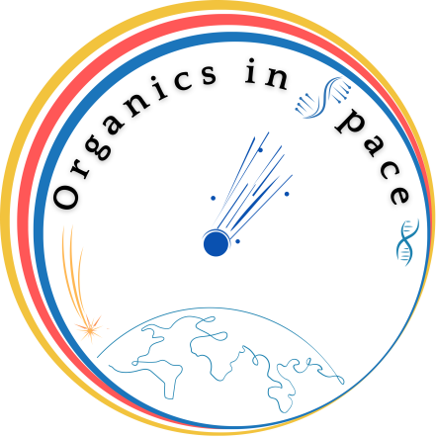

**The deadline for receipt of abstracts is June 20, 2025.**

**References**

1. Y. Ling and C. Lifshitz, Chem. Phys. Lett. 257, 587 (1996).
2. Y. Ling and C. Lifshitz, Chem. Phys. Lett. 257, 587 (1996).

List and number all references at the end of the paper as follows. When referring to them in the text, type the corresponding reference number between brackets (e.g., [1, 2]).